

College of Social Work

Stillman Hall
1947 College Rd.
Columbus, OH 43210-1162
Phone (614) 292-6288
Fax (614) 292-6940

March 5, 2010

Dr. W. Randy Smith
Vice Provost
Office of Academic Affairs
203 Bricker Hall
190 N. Oval Mall

Dear Dr. Smith:

This letter is being written in order to request that Social Work 220 be considered for an Autumn Quarter 2010 start date.

Social Work 220 has been developed to meet the requirements of the “Introduction to Social Welfare” Social Work TAG course, and will be a pre-major requirement for all social work majors. It has also been submitted for consideration as a Social Science GEC. While this Social Work TAG course will be a good fit for our semester curriculum, it was a challenge to determine how best to insert this course into our current curriculum without creating redundancy. After considering several options, a decision was made to eliminate Social Work 520 from our major curriculum and to make minor adjustments to Social Work 230 in order to accommodate the Social Work 220 TAG. Arriving at this decision was a more timely process than anticipated, and thus Social Work 220 was not initiated on the Electronic Course Approval system during the time frame necessary to seek an Autumn Quarter 2010 start date.

As Social Work 220 will become a pre-major requirement for social work major applicants, we would like to provide students the flexibility and opportunity to enroll in this course during each quarter of the 2010-2011 academic year, and therefore are requesting consideration for an Autumn 2010 start date.

Thank you for your consideration. If you have any questions or need further information, please contact me at (614) 292-5471 or babcock.79@osu.edu.

Sincerely,
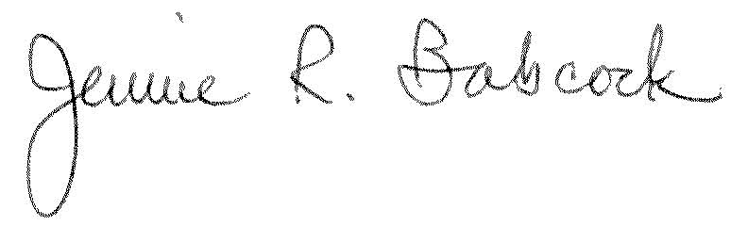

Jennie R. Babcock, MSW, LISW-S
Director of Undergraduate Studies

